**Geography Policy**

St Laurence in Thanet Church of England Junior Academy

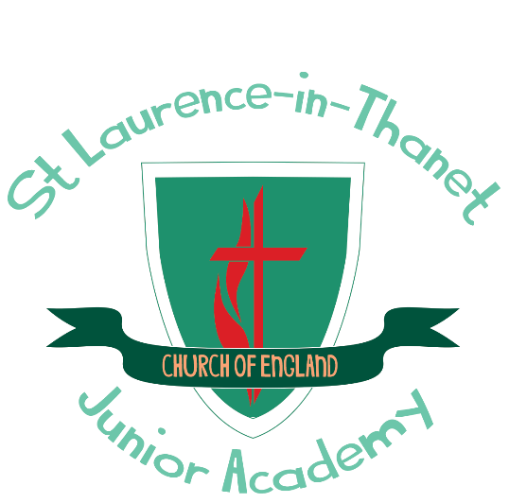

**Our school offers a supportive, inclusive, nurturing and inspiring learning environment where each member is known by God, loved and empowered to reach their full potential. Children are encouraged through an aspirational and engaging curriculum to develop their knowledge, skills and character so that they can truly flourish, both now and into the future.**

This set of values is reflected in all our policies.

Joy Hope Forgiveness Love Resilience

|  |  |  |
| --- | --- | --- |
| **Approved by:** | J Spencer | **Date:** April 2025 |
| **Last reviewed on:** | April 2025 | |
| **Next review due by:** | April 2027 | |

**Introduction**

This policy outlines the purpose, nature and management of the Geography taught and learnt in our school. It has been adopted by the staff of St Laurence C of E Junior Academy. This policy outlines the guiding principles by which this school will implement Geography.

**Rationale for Geography teaching**

The aim of teaching Geography is to teach an understanding of space, place and scale. We teach children about their local area, and they compare their life in this area with that in other regions in the United Kingdom and in the rest of the world. The children also learn how to draw and interpret maps, alongside developing their own research skills, these include investigation, evaluation and problem solving. Geography teaching also motivates children to find out about the physical world, and enables them to recognise the importance of being a global citizen and to have an awareness for the future of mankind.

**Aims for the teaching of Geography at St Laurence C of E Junior Academy**

At St Laurence our intention is to provide quality teaching and learning of Geography. We aim:

* to enable children to gain awareness and understanding of places in the world;
* to increase children’s knowledge of other cultures
* to enable children to understand environmental problems at a local, regional and global level;
* to inspire in children a commitment to sustainable development, and an appreciation of what ‘global citizenship’ means;
* to cultivate in children a variety of other skills, including those of enquiry, problem-solving, ICT, investigation, and that of presenting their conclusions in the most appropriate way
* to develop the cross-curricular use of Geography in all subjects

**Teaching and learning**

We use a variety of teaching and learning styles in our geography lessons and have adopted an enquiry based learning method. We use whole class teaching methods, combined with enquiry based activities to allow the children to have ownership over their learning. We encourage our Geographers to ask and answer geographical questions and use a variety of data, maps, pictures and technology to do this. As part of our enquiry based learning, the children present their findings at the end of a unit either to their class or parents. Wherever possible, we involve the children in ‘real’ geographical activities, e.g. research of a local road and the implications of it widening and an archaeological dig.

**The role of the Geography subject leader is:**

* Taking the lead in the development, evaluation and amendment of schemes of work
* Acting as a consultant to colleagues
* Monitoring and evaluating children’ work, children’ views about the subject and planning
* Auditing and ordering resources when needed
* Keeping up to date with developments in Geography and disseminating information to the rest of the teaching staff. Attending relevant CPD and prompting others about relevant training
* Leading staff meetings as appropriate

**Geography curriculum planning**

Geography is a foundation subject in the National Curriculum. We use an enquiry based learning process**,** supported by resources developed by the Oddizzi as a basis for our curriculum planning. There is a strong focus on using our local area in our planning and this runs through the curriculum. Something which is recognised by the school being awarded the Heritage Schools programme award by Historic England. We use the national scheme of work as the basis for our long and medium-term plans, which the subject leader reviews regularly. Each lesson will have an LQ (Learning question) that feeds into the over arcing EQ (Enquiry question) along with a Success Criteria which lists specific objectives and expected outcomes for the lesson. Children of all abilities have the opportunity to develop their skills and knowledge in each unit and, through planned progression built into the scheme of work, we offer them an increasing challenge as they move up the school.

**Key Stage 2**

The National Curriculum Programme of Study at Key Stage 2 should extend children’s knowledge and understanding beyond the local area to include the United Kingdom and Europe, North and South America. This will include the location and characteristics of a range of the world’s most significant human and physical features. The children should develop their use of geographical knowledge, understanding and skills to enhance their locational and place knowledge. Pupils are taught to use Locational knowledge, Place knowledge, Human and Physical Geography and Geographical skills and fieldwork.

**Fieldwork**

Fieldwork is integral to good geography teaching, and we include as many opportunities as we can to involve children in practical geographical research and enquiry. Across the key stage, the children have more than one opportunity to study the local area. Units based on our local coast, St Lawrence itself, the Ramsgate tunnels alongside the opportunity to take part in a residential trip at the end of Year 6 are just some of our fieldwork opportunities.

**Cross Curricular links**

**Literacy** – Geography can be seen throughout Literacy as it makes a significant contribution by actively promoting the skills of reading, writing, speaking and listening. Across the Literacy curriculum, Geographical texts are used as a focus in certain units and our library is stocked with a wide range of diverse geographic reading materials. Reports, letters and recording information will all develop children’s writing ability.

**Numeracy** - The teaching of Geography in our school contributes to children’s mathematical understanding in a variety of ways. The children are presented with maps, they study space, scale and distance, and they learn how to use four- and six-figure grid references. They also use graphs to explore, analyse and clarify a variety of data.

**Computing** - Children use computing in Geography to enhance their skills in data handling and in presenting written work, and they research information using the Internet, including the reliability of information and sources.

**PSHE** – Our children are given many opportunities to explore and discussion a variety of questions in life via their Geography in our school. The subject matter lends itself to raising matters of citizenship and social welfare. For example, units based on the changing landscape and theme days to highlight environmental issues leads children to ask questions about the evolution of the planet. Through teaching about contrasting localities, we enable the children to learn about inequality and injustice in the world. The children further develop their knowledge and understanding of different cultures, so that they learn to avoid stereotyping other people, and acquire a positive attitude towards others.

**Assessment**

Formative assessment is use to monitor student learning and provide ongoing feedback to the children during the unit of work. At the end of a unit, summative assessment is used to evaluate learning by completing the assessment spreadsheet based on the progression of skills.

**Marking**

Feedback to children should be provided on their attainment against the objectives of Geography. Children are encouraged to improve their own learning performance through the school feedback policy.

**Monitoring and review**

The coordination and planning of the Geography curriculum are the responsibility of the subject leader. The subject leader is responsible for evaluating the strengths and weaknesses in Geography and indicating areas for further improvement on the following action plan. The subject leader will also monitor Geography books and schemes of work to ensure that the Programmes of Study are being effectively taught and match the needs and abilities of the children

**Inclusion and differentiation**

At our school, we teach Geography to all children, whatever their ability and individual needs. Geography forms part of the school curriculum policy to provide a broad and balanced education to all children. Through our Geography teaching, we provide learning opportunities that enable all children to make good progress. We strive hard to meet the needs of those children with special educational needs, those with disabilities, those with special gifts and talents, and those learning English as an additional language, and we take all reasonable steps to achieve this. We use a range of strategies to support and challenge children, such as InPrint for accessible word mats and the use of ‘What if’ questions for higher order thinking.

**Resources**

There are sufficient resources for all Geography teaching units in the school. We keep these resources in a central store, where there are class sets of globes, compasses, maps and atlases. The library contains a good supply of topic books and access to the Internet to support the children’s individual research